Apply for DMC Access

The Data Management Center (DMC) allows district users to monitor and validate data that has been loaded into their IODS. Depending on the roles assigned users may request Keys and Secrets, review Level 1.5 Filters, schedule and run L2 Validations, view their Load Summary, and Search Data.

Note: It is suggested that only one person at the district has the DMC LEA Technical role.

DMC Roles:

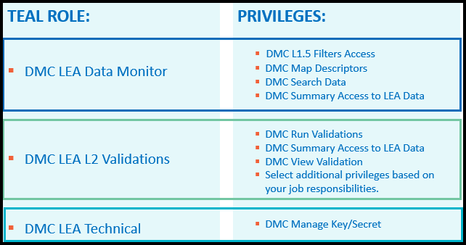

- Log into TEAL.
- Click Add/Modify Access.
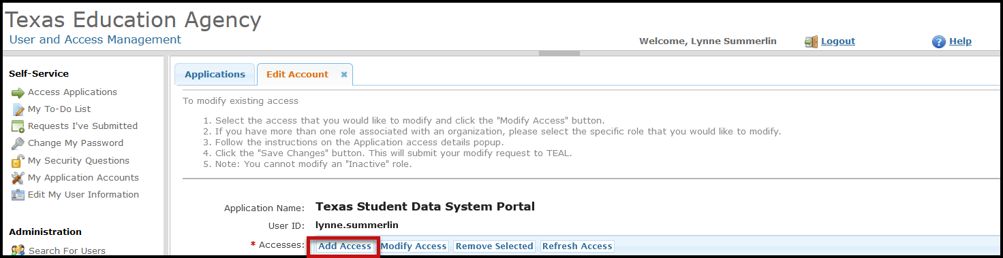
- Click on Add Access.

DMC LEA Data Monitor:
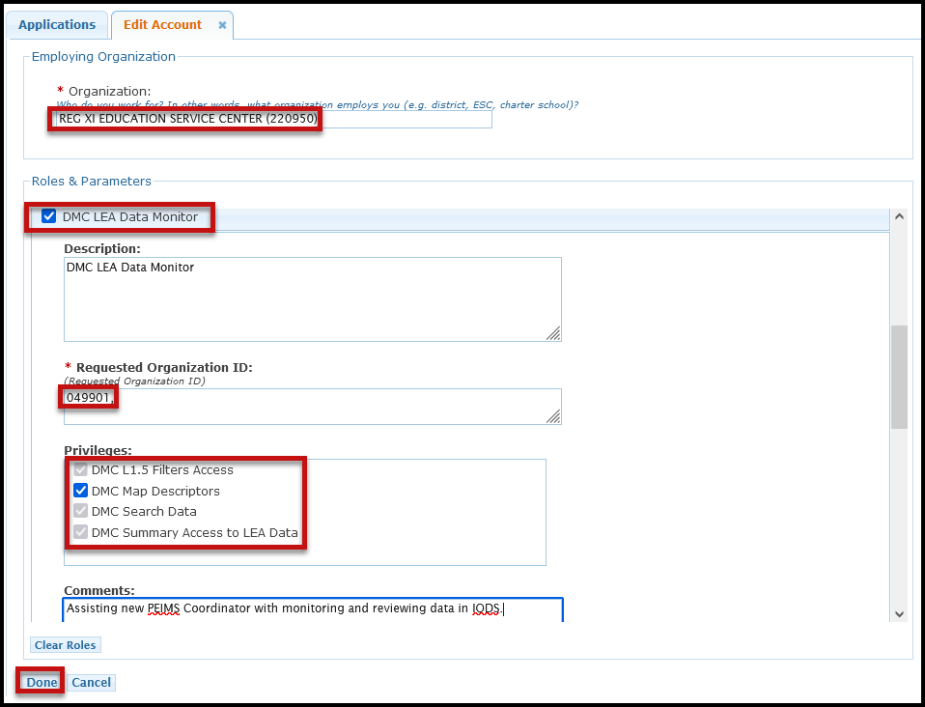
- In the Organization field, enter your employing district/charter county district number.
- Select DMC LEA Data Monitor.
- In the Requested Organization ID, enter your district/charter county district number.
- Under Privileges, select all the privileges.
- Click Done if this is the only role you are requesting.
- Click *Save Changes*. It is important that you click Save Changes before you exit the screen.

DMC LEA L2 Validations:
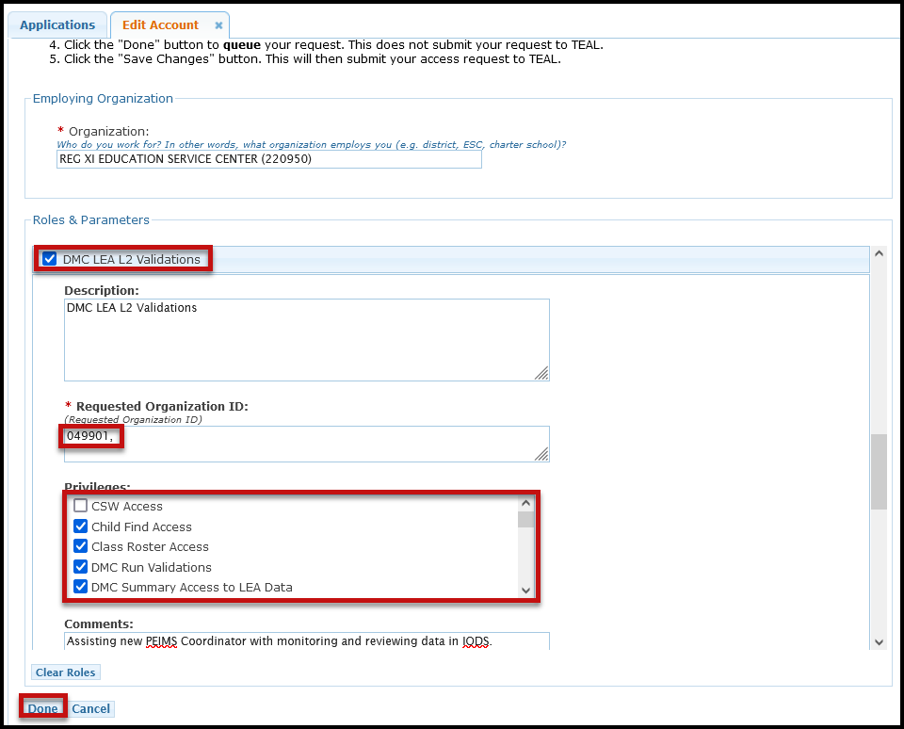
- In the Organization field, enter your employing district/charter county district number.
- Select DMC LEA L2 Validations.
- In the Requested Organization ID, enter your district/charter county district number.
- Under Privileges, select the appropriate privileges.
- Click Done if this is the only role you are requesting.
- Click *Save Changes*. It is important that you click Save Changes before you exit the screen.

DMC LEA Technical (Suggested only one district person have access to this role):
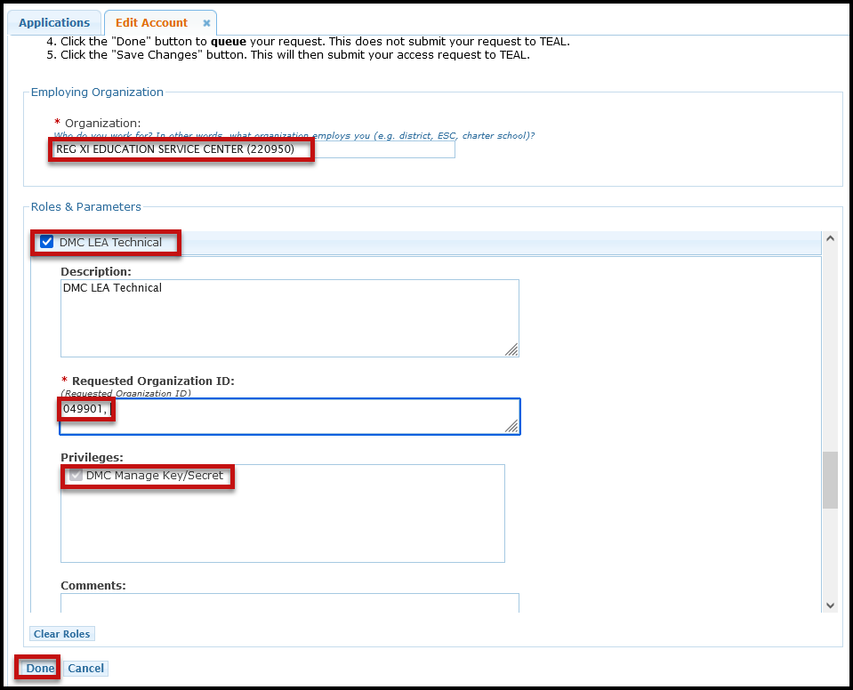
- In the Organization field, enter your employing district/charter county district number.
- Select DMC LEA Technical.
- In the Requested Organization ID, enter your district/charter county district number.
- Under Privileges, verify DMC Manage Key/Secret is selected.
- Click Done if this is the only role you are requesting.
- Click *Save Changes*. It is important that you click Save Changes before you exit the screen.

